JVM Architecture :

JVM- Java Virtual Machine
JavaScript and Python, the computer executes the instructions directly without having to compile them. These languages are called interpreted languages.
Java code first compile and generate .class file. .class file interpreted by JVM

Java File(.java) --- > Compile using javac (byte code .class) ---- > send to JVM for execution

JVM consists of 3 components:
- Class Loader
- Runtime Memory/Data Area
- Execution Engine

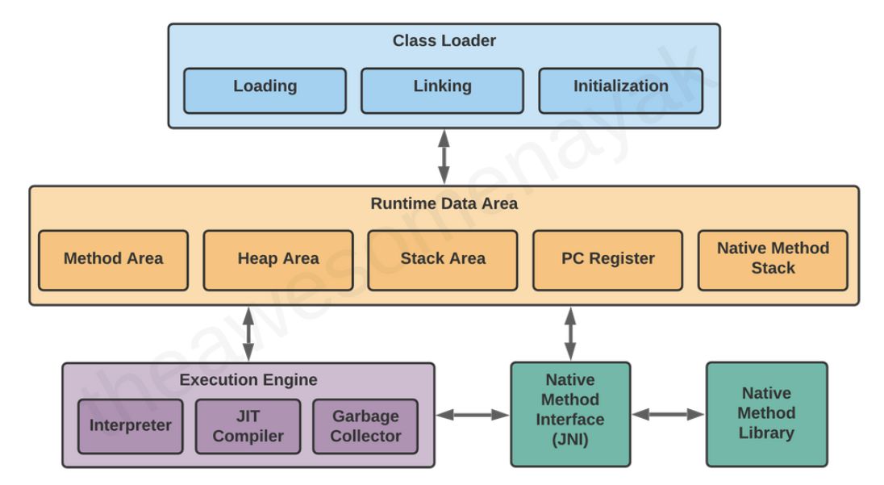

Class Loader :
- Class loader loads .class file into the main memory.
- First load the class that contains main()
- Three phases in the class loading process: loading, linking, and initialization

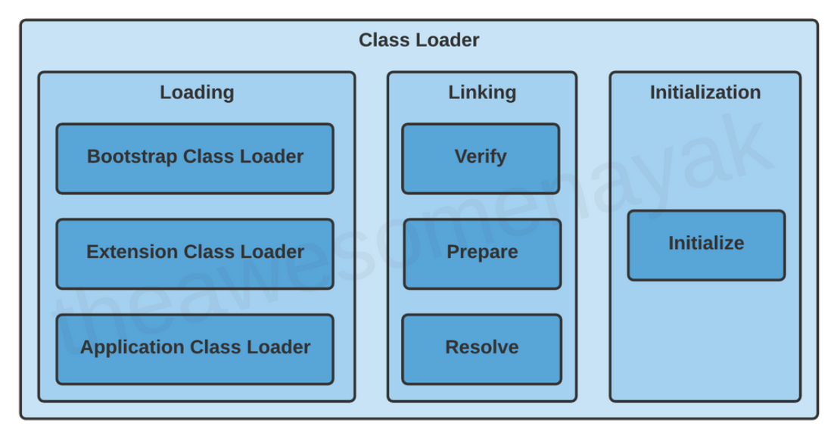

Loading:
There are three built-in class loaders available in Java:
- Bootstrap Class Loader
Load java.lang, java.net, java.util, java.io and libraries present in the $JAVA_HOME/jre/lib directory.
- Extension Class Loader
This loads the extensions of standard Java libraries which are present in the $JAVA_HOME/jre/lib/ext directory.
- Application Class Loader
It loads the files present on the classpath.
If a parent class loader is unable to find a class in any class loader, it throws NoClassDefFoundError or ClassNotFoundException.
Linking :
Linking includes the following steps:
Verification: This phase checks the structural correctness of the .class file by checking it against a set of constraints or rules.
For example, if the code has been built using Java 11, but is being run on a system that has Java 8 installed, the verification phase will fail.
Preparation: In this phase, the JVM allocates memory for the static fields of a class or interface, and initializes them with default values.
Resolution: In this phase, symbolic references are replaced with direct references present in the runtime constant pool.

Initialization :
This can include calling the class's constructor, executing the static block, and assigning values to all the static variables

Runtime Data Area :
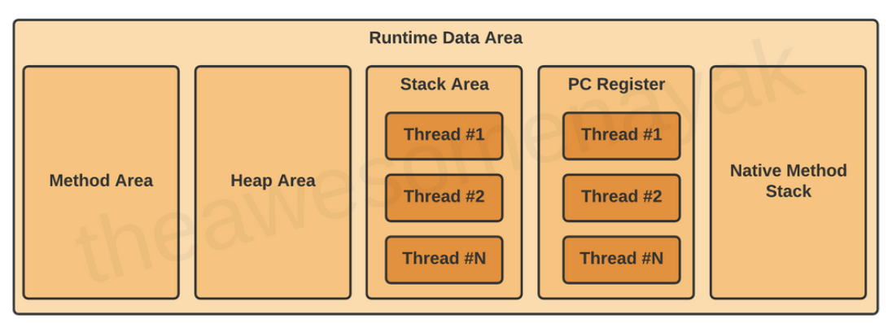
Method Area:
All the class level data such as the run-time constant pool, field, and method data, and the code for methods and constructors, are stored here.
If the memory available in the method area is not sufficient for the program startup, the JVM throws an OutOfMemoryError.
Ex:
public class Employee {
private String name;
private int age;
public Employee(String name, int age) {
this.name = name;
this.age = age;
}
}
In this code example, the field name and age and the constructor details are loaded into the method area.
Heap Area :
All the objects and their corresponding instance variables are stored here.
Stack Area :
Whenever a new thread is created in the JVM, a separate runtime stack is also created at the same time. All local variables, method calls, and partial results are stored in the stack area.
Stack Area follow Last-in First-out (LIFO)
- It create as many no of thread created that many no of stacks.
- It stores primitive datatype and reference variable
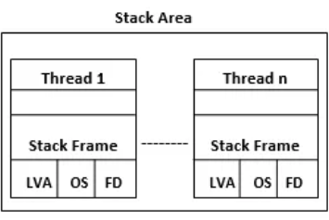
The Stack Frame is divided into three sub-parts:
- Local Variables
- Operand Stack
- Frame Data
Program Counter (PC) Registers :
The JVM supports multiple threads at the same time. Each thread has its own PC Register to hold the address of the currently executing JVM instruction. Once the instruction is executed, the PC register is updated with the next instruction.
Native Method Stacks :
The JVM contains stacks that support native methods. These methods are written in a language other than the Java, such as C and C++. For every new thread, a separate native method stack is also allocated.

Execution Engine :
Once the bytecode has been loaded into the main memory, and details are available in the runtime data area, the next step is to run the program. The Execution Engine handles this by executing the code present in each class.

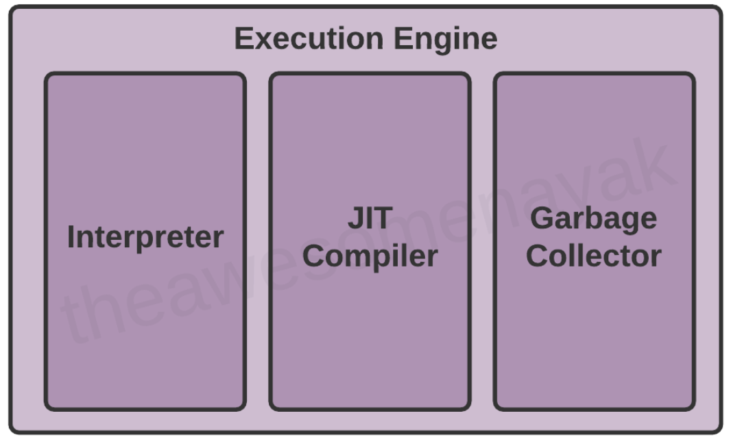
Interpreter
The interpreter reads and executes the bytecode instructions line by line. Due to the line by line execution, the interpreter is comparatively slower.
It converts bytecode instructions to machine learning code.
JIT Compiler :
The JIT Compiler overcomes the disadvantage of the interpreter. The Execution Engine first uses the interpreter to execute the byte code, but when it finds some repeated code, it uses the JIT compiler.

Garbage Collector :
The Garbage Collector (GC) collects and removes unreferenced objects from the heap area.
calling System.gc() is not guaranteed.
The JVM contains 3 different types of garbage collectors:
- Serial GC - It uses a single thread for garbage collection. When it runs, it leads to a "stop the world" event where the entire application is paused. The JVM argument to use Serial Garbage Collector is -XX:+UseSerialGC
- Parallel GC - This is the default implementation of GC in the JVM, and is also known as Throughput Collector. It uses multiple threads for garbage collection, but still pauses the application when running. The JVM argument to use Parallel Garbage Collector is -XX:+UseParallelGC.
- Garbage First (G1) GC - G1GC was designed for multi-threaded applications that have a large heap size available (more than 4GB). It partitions the heap into a set of equal size regions, and uses multiple threads to scan them. G1GC identifies the regions with the most garbage and performs garbage collection on that region first. The JVM argument to use G1 Garbage Collector is -XX:+UseG1GC
Note: There is another type of garbage collector called Concurrent Mark Sweep (CMS) GC. However, it has been deprecated since Java 9 and completely removed in Java 14 in favour of G1GC
Java Native Interface (JNI) :
At times, it is necessary to use native (non-Java) code (for example, C/C++).
Native Method Libraries :
Native Method Libraries are libraries that are written in other programming languages, such as C, C++, and assembly. These libraries are usually present in the form of .dll or .so files. These native libraries can be loaded through JNI.

Common JVM Errors :
ClassNotFoundExcecption - This occurs when the Class Loader is trying to load classes using Class.forName(), ClassLoader.loadClass() or ClassLoader.findSystemClass() but no definition for the class with the specified name is found.
NoClassDefFoundError - This occurs when a compiler has successfully compiled the class, but the Class Loader is not able to locate the class file at the runtime.
OutOfMemoryError - This occurs when the JVM cannot allocate an object because it is out of memory, and no more memory could be made available by the garbage collector.
StackOverflowError - This occurs if the JVM runs out of space while creating new stack frames while processing a thread.

Components | Memory
Static Variable | Method Area
Methods
Method local variable
Object
Constructor
Array
Global variables/ Instance Variable | Heap

Memory Management

Java 7 and Java 8 memory management
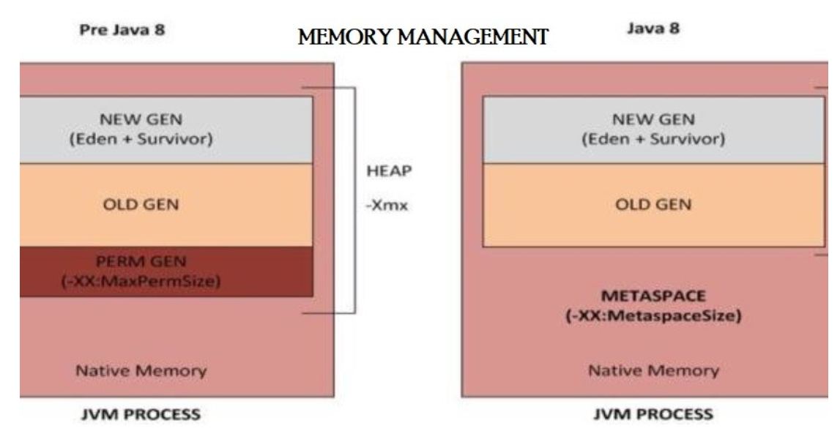

Java Memory Model :
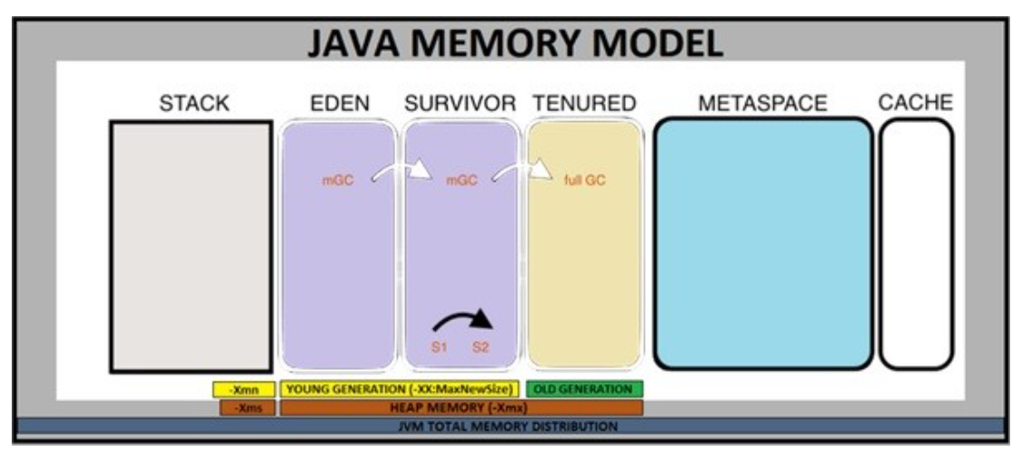
- Heap Space: Eden + Survivor + Tenured
- Non-Heap Space: Stack + MetaSpace + Reserved (Not shown here)
- Cache
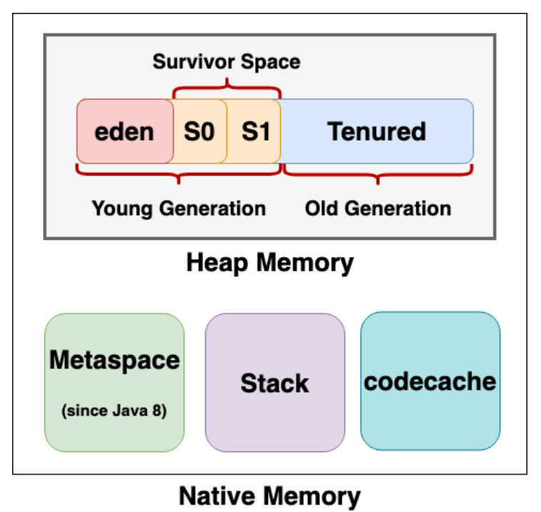
Young Generation: All the new objects are allocated in this memory. Whenever this memory gets filled, the garbage collection is performed. This is called as Minor Garbage Collection. Young Generation is divided into three parts – Eden and two Survivor(S1, S2) Memory Spaces. All newly created objects are placed in the Eden Space.

Old Generation: This is also known as Tenured Space. All the long lived objects which have survived many rounds of minor garbage collection is stored in this area. Whenever this memory gets filled, the garbage collection is performed. This is called as Major Garbage Collection.
Metaspace: From Java 8 onwards, Permanent Generation has been replaced with MetaSpace, which is a non-heap memory. MetaSpace holds the reflective data of JVM itself, like Class Loader related data, Class metadata, methods and more. MetaSpace is not a contiguous memory and can auto increase its size up to the limit that underlying OS allows, whereas Perm Gen always has a fixed maximum size. As long as the classloader is alive, the metadata remains alive in the Metaspace and can’t be freed.
- **Metaspace store long live data like – Static variables
- Static variables store in method area [method area is common for all the threads]

ChatGPT:
- Heap Memory: Used for dynamic memory allocation. All objects and their instance variables are stored here.
- Method Area (also called the Metaspace in Java 8 and later): Stores class-level data such as class definitions, static variables, and constants.
- Stack Memory: Stores method call frames, including local variables and method parameters.
- PC Registers: Each thread has its own PC register that stores the address of the current execution instruction.
- Native Method Stack: Contains all the native method information.

